Practical 2
Part A
1) | Smart thermostat (Thermostat.java, main in this file)  (a) Create class Thermostat with private String location, private int temperature, private  static final int MIN=16 and MAX=30, and private static int activeCount=0.  (b) Constructor(location, startTemp): store location; set temperature to startTemp if it is  within MIN..MAX else 22; increment activeCount.  (c) Constructor(location): chain with this(location, 22).  (d) raise(): if temperature < MAX add 1, else print “Already at maximum (30)”.  (e) lower(): if temperature > MIN subtract 1, else print “Already at minimum (16)”.  (f) Add getTemperature() (no setter) and static getActiveCount().  (g) In main: create two thermostats, call raise() 10 times then lower() 20 times in loops  (printing the temperature each time), then print getActiveCount().
 | Thermostat.java
Code | public class Thermostat {  private String location;  private int temperature;  private static final int MIN = 16, MAX = 30;  private static int activeCount = 0;  Thermostat(String location, int startTemp) {  this.location = location;  temperature = 22;  if (startTemp >= MIN && startTemp <= MAX) { temperature = startTemp; }  activeCount++;  }  Thermostat(String location) { this(location, 22); }  void raise() {  if (temperature < MAX) { temperature++; }  else { System.out.println("Already at maximum (30)"); }  }  void lower() {  if (temperature > MIN) { temperature--; }  else { System.out.println("Already at minimum (16)"); }  }  int getTemperature() { return temperature; }  static int getActiveCount() { return activeCount; }  public static void main(String[] args) {  Thermostat a = new Thermostat("Room 1");  Thermostat b = new Thermostat("Room 2", 24);  for (int i = 0; i < 10; i++) {  a.raise(); System.out.println(a.getTemperature());  }  for (int i = 0; i < 20; i++) {  a.lower(); System.out.println(a.getTemperature());  }  System.out.println("Active: " + getActiveCount());  }  }
Output | 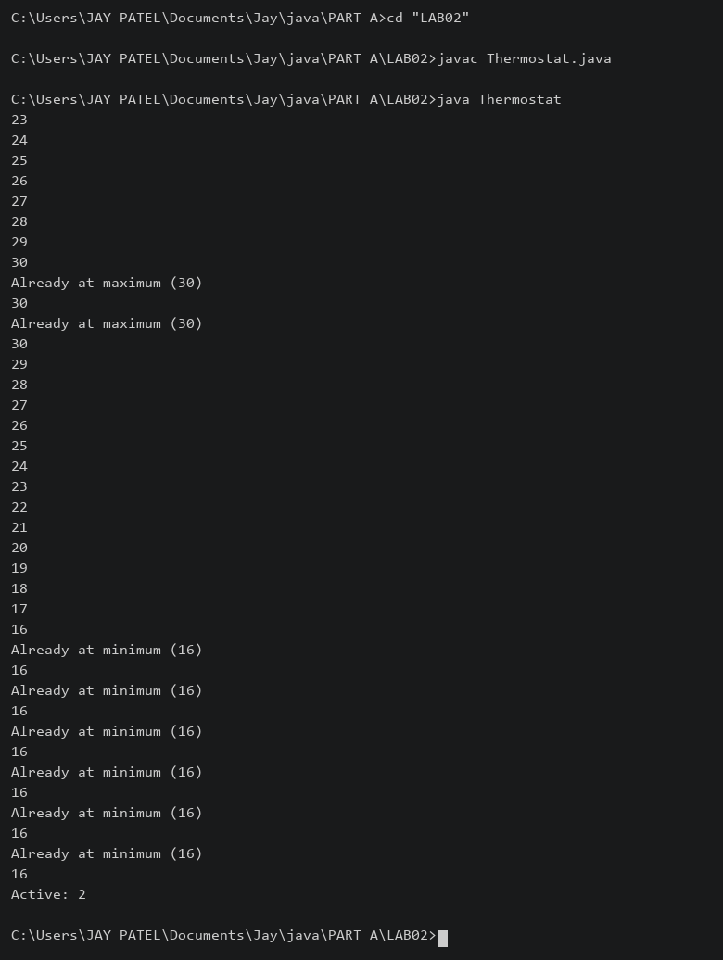

2) | Cinema show (CinemaShow.java, main in this file)  (a) Create class CinemaShow with private String title, private int seatsAvailable, private  final int capacity, and private static int totalBooked=0.  (b) Constructor(title, capacity): set both and seatsAvailable = capacity.  Constructor(title): chain with this(title, 100).  (c) book(int n): if n ≤ seatsAvailable, reduce seatsAvailable by n, add n to totalBooked,  return true; else return false unchanged.  (d) cancel(int n): increase seatsAvailable by n but never above capacity.  (e) Add getSeatsAvailable() and static getTotalBooked().  (f) In main: run a sequence of book and cancel calls, printing the result and seats after  each, then print getTotalBooked().
 | CinemaShow.java
Code | public class CinemaShow {  private String title;  private int seatsAvailable;  private final int capacity;  private static int totalBooked = 0;  CinemaShow(String title, int capacity) {  this.title = title;  this.capacity = capacity;  seatsAvailable = capacity;  }  CinemaShow(String title) { this(title, 100); }  boolean book(int n) {  if (n > 0 && n <= seatsAvailable) {  seatsAvailable -= n; totalBooked += n; return true;  }  return false;  }  void cancel(int n) {  if (n > 0) { seatsAvailable = Math.min(capacity, seatsAvailable + n); }  }  int getSeatsAvailable() { return seatsAvailable; }  static int getTotalBooked() { return totalBooked; }  public static void main(String[] args) {  CinemaShow s = new CinemaShow("Movie", 10);  System.out.println(s.book(6) + " Seats: " + s.getSeatsAvailable());  System.out.println(s.book(8) + " Seats: " + s.getSeatsAvailable());  s.cancel(2);  System.out.println("After cancel: " + s.getSeatsAvailable());  System.out.println(s.book(3) + " Seats: " + s.getSeatsAvailable());  System.out.println("Total booked: " + getTotalBooked());  }  }
Output | 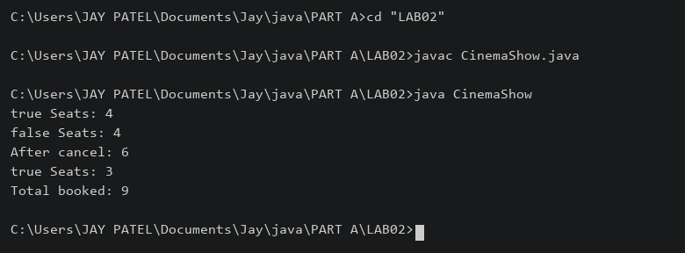

3) | (For Advanced Learners – home) Parking lot (ParkingLot.java)  (a) Create class ParkingLot with private int twoWheelers and fourWheelers, private final  int twoCap and fourCap, and private static long revenue=0.  (b) park(String type): for “two”, if twoWheelers < twoCap increment and add 20 to  revenue; for “four”, if fourWheelers < fourCap increment and add 40; otherwise print  “Full” and reject.  (c) leave(String type): decrement the matching count but never below 0.  (d) In main: simulate a sequence of park/leave events, printing each outcome, then print  final occupancy and revenue.
 | ParkingLot.java
Code | public class ParkingLot {  private int twoWheelers, fourWheelers;  private final int twoCap, fourCap;  private static long revenue = 0;  ParkingLot(int twoCap, int fourCap) {  this.twoCap = twoCap; this.fourCap = fourCap;  }  void park(String type) {  if (type.equals("two") && twoWheelers < twoCap) {  twoWheelers++; revenue += 20; System.out.println("Two parked");  } else if (type.equals("four") && fourWheelers < fourCap) {  fourWheelers++; revenue += 40; System.out.println("Four parked");  } else { System.out.println("Full or invalid type"); }  }  void leave(String type) {  if (type.equals("two") && twoWheelers > 0) { twoWheelers--; }  else if (type.equals("four") && fourWheelers > 0) { fourWheelers--; }  System.out.println("Occupancy: " + twoWheelers + ", " + fourWheelers);  }  public static void main(String[] args) {  ParkingLot p = new ParkingLot(1, 1);  p.park("two"); p.park("two"); p.park("four");  p.leave("two"); p.park("two");  System.out.println("Final: " + p.twoWheelers + ", " + p.fourWheelers);  System.out.println("Revenue: " + revenue);  }  }
Output | 

